RET — Timing Evidence Report
• Team: Rafael Ricardo Torres Choperena
• Boards: NUCLEO-L476RG, native_sim/native/64
• AI use: Week 1: Antigravity (Gemini) — initial RET structure and EARS task set table.
Living document — updated every week; handed in at the workshop (week 7) and at the close (week 14).
House rule: "show me the trace" — every timing claim cites a measurement.
1. The system and its task set
Requirements first — one sentence each, EARS style (when/while <condition>, the system shall <response> within <deadline>) — then the task that implements them:
ID | Requirement
REQ-SAMP-01 | While the node is powered on, the system shall sample the pressure sensor, check the e-stop condition, and update the valve PWM phase every 1 ms (1 kHz) with bounded jitter.
REQ-CTRL-01 | While the system is irrigating, the control loop shall compute the PI control law and update the valve duty cycle every 10 ms (deadline = period).
REQ-ESTOP-01 | When an overpressure condition is detected, the system shall close the valve and trip the emergency stop within 5 ms.
REQ-CONS-01 | When an operator sends a command over the UART console, the system shall parse and respond within 100 ms.
REQ-TELE-01 | While the system is running, the node shall transmit a CSV telemetry line every 1000 ms (1 Hz).
REQ-DISP-01 | While the local OLED HMI is enabled, the system shall refresh the display every 500 ms (2 Hz).

Task | Req. | Type (H/F/S) | Period | Deadline | Measured C_i | How it was measured
Sensor sampling | REQ-SAMP-01 | Hard | 1 ms | = T | ____ | <GPIO + analyzer / trace>
Control loop | REQ-CTRL-01 | Hard | 10 ms | = T | ____ | <GPIO + analyzer / trace>
Overpressure e-stop | REQ-ESTOP-01 | Hard | 1 ms (polled) | 5 ms | ____ | <GPIO + analyzer / trace>
Command console | REQ-CONS-01 | Firm | Sporadic | 100 ms | ____ | <GPIO + analyzer / trace>
Telemetry to the Hub | REQ-TELE-01 | Soft | 1000 ms | 1000 ms | ____ | <GPIO + analyzer / trace>
Display HMI (optional) | REQ-DISP-01 | Soft | 500 ms | 500 ms | ____ | <GPIO + analyzer / trace>

2. ADRs
ADR-001 — <title>
Context: … · Decision: … · Justification (with numbers): … · Status: …
3. Evidence by week
Each entry cites the REQ(s) it verifies.
Week 1 — Bring-up: the team, the board, the toolchain
Quantity | Prediction | Your value | Target
Edit → build (-p) → flash → message on the console, one member's laptop | 25 s | 42.33 s | < 60 s
Same, incremental build (one line changed, no -p) | 5 s | 5.09 s
Members with blinky running from their own laptop |  | 1 / 1 | all

Task A — Blinky running on NUCLEO-L476RG
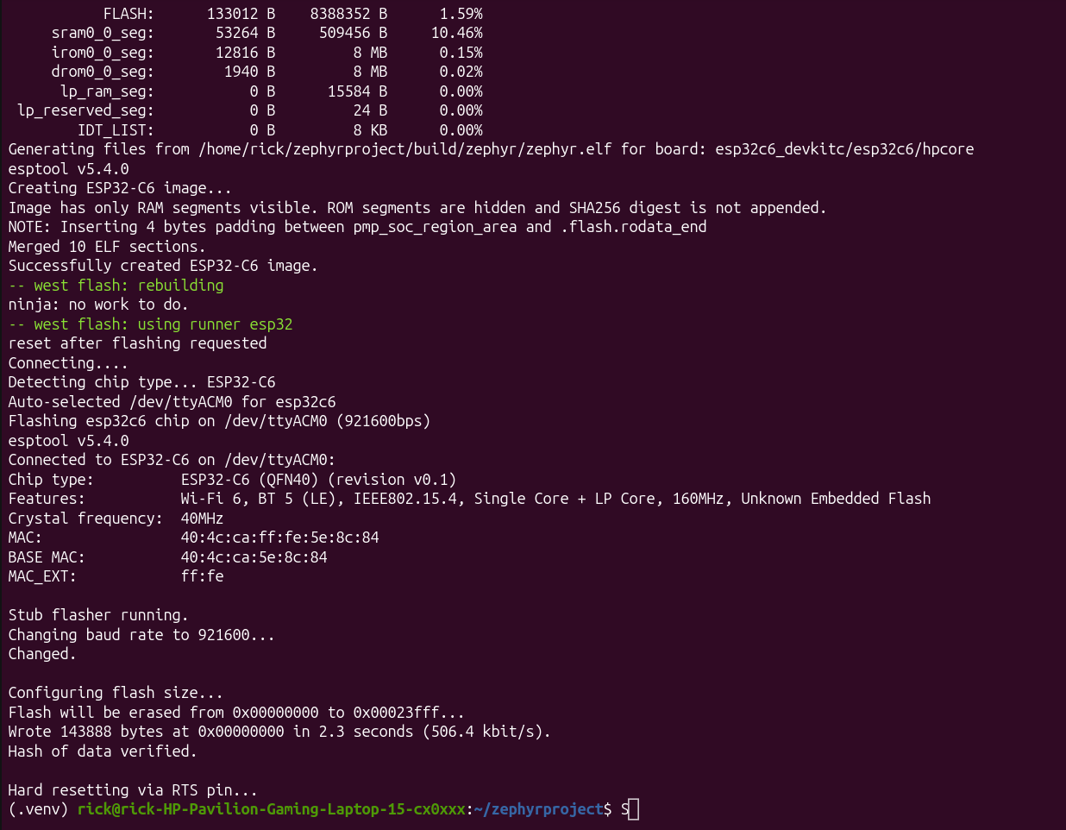
Figura 1 interfaz ubuntu con el entorno activado y el programa flasheado y compilado

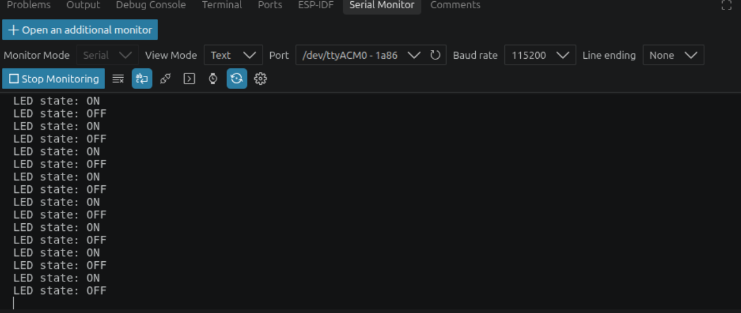
Figura 2 Programa corriendo

Task B — Serial console (115200 8N1) with modified hello_world message & cycle times
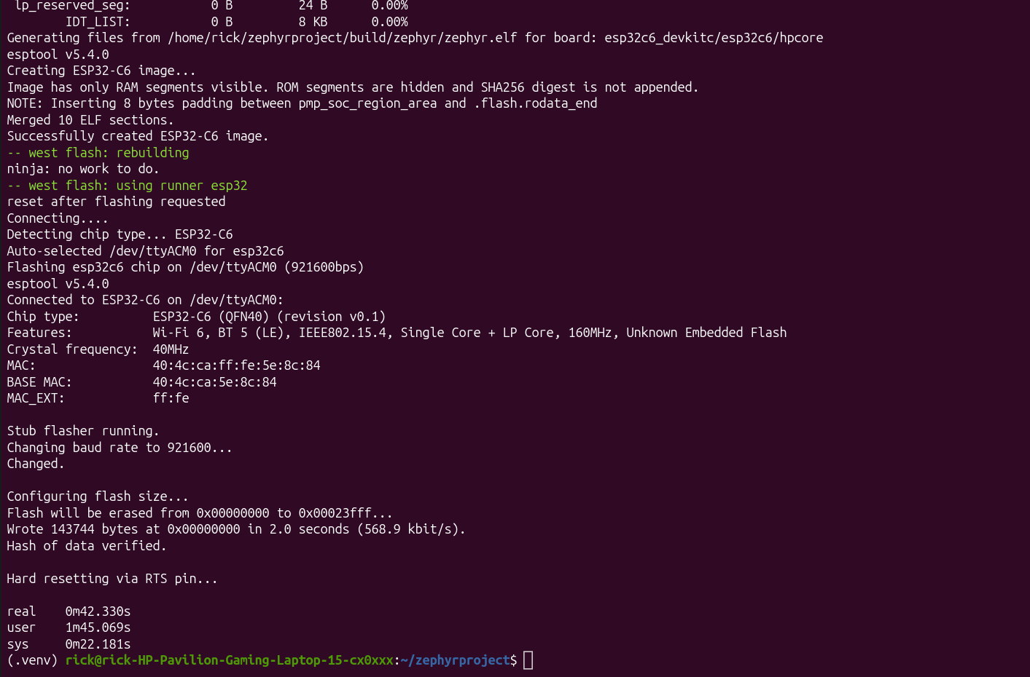
Figura 3 real = 42.33s
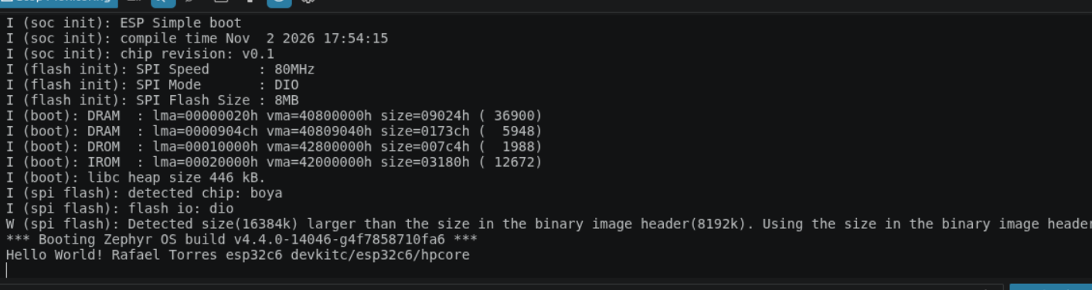
Figura 4 hello world desde la consola
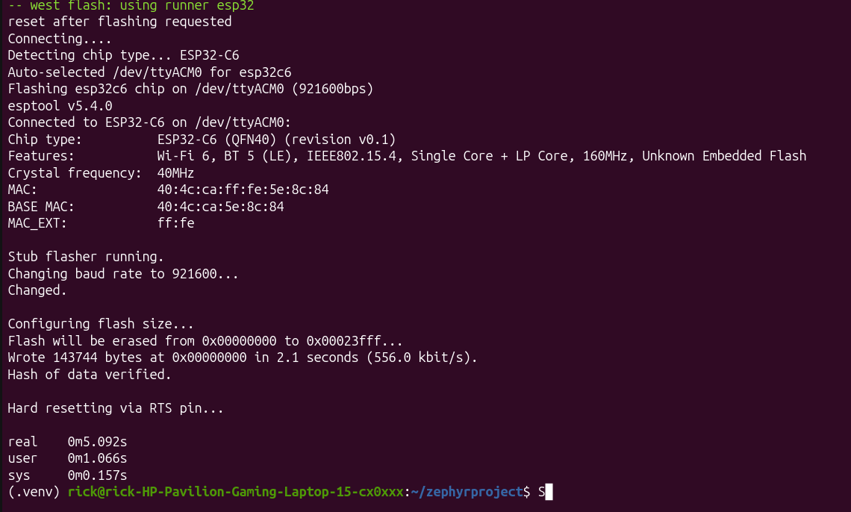
Figura 5 real = 5.09s

Week 2 — superloop baseline (state the board)
<jitter/latency table + a one-sentence reading>
4. Schedulability analysis
U = ΣC_i/T_i with measured C_i; test used (RM / hyperbolic / EDF); RTA as a script with its output; blocking B_i if there are mutexes.
5. Functional safety (final project)
Declared safe state (failure ⇒ valve closed), watchdog, and the evidence of the fail-safe firing.
6. Agent-built components (final project)
The Hub's GUI and routing, built by an agent from spec/hub-soft.md.

